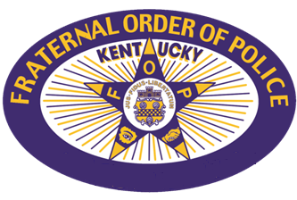
Covington FOP Lodge #1 Fallen Officer Scholarship
Please fill out all fields and email application to CovingtonFOPScholarship@gmail.com
Or mail to 516 E 18th St, Covington, KY 41014
Name: _______________________________________________________________________
Home Address: ________________________________________________________________
Phone Number: _______________________________________________________________
Email Address: ________________________________________________________________
Age at Graduation: __________
Name of Parent/Guardian: ______________________________________________________
FOP or FOPA Member?___________
High School: __________________________________________________________________
Graduation Year: __________
Overall GPA: __________
List any clubs or organizations in which you are involved:
__________________________________________________________________________________________________________________________________________________________________________________________________________________________________________
Other Extracurriculars:
____________________________________________________________________________________________________________________________________________________________
What are you planning on studying in college?
______________________________________________________________________________
What college do you plan on attending?
______________________________________________________________________________Please complete a short, original, previously unpublished essay answering the question, "What does Covington mean to me?" The essay must be between 400 and 700 words in length.
All applications must be received by July 1st, 2024 to be considered.

